# **Overview**

**Household Tenure**

This resource involves investigation of household tenure as reported in the 2011 Census. Students are provided with suggested background reading in order to introduce the topic and then they explore the datasets in DataNation to understand the pattern of Socially Rented accommodation across Britain and in more detail across Scotland. This resource also includes a data handling exercise, exporting data from DataNation for manipulation in Excel.

This exercise can easily be adapted to suit your own local area, region or country. Provide background reading to start by finding article relating to housing issues and initiatives in your area. Then follow the analysis and comparing exercises to explore the patterns relevant to your area.

# **Starter**

Begin by introducing the subject of affordable housing and social housing with the following news articles:

1. [£568m for affordable housing: https://news.gov.scot/news/gbp-568m-for-affordable- housing](https://news.gov.scot/news/gbp-568m-for-affordable-housing)
2. North Sighthill to be transformed with £35m mixed tenure housing development: <http://www.scottishhousingnews.com/17182/north-sighthill-to-be-transformed-with-> [35m-mixed-tenure-housing-development/](http://www.scottishhousingnews.com/17182/north-sighthill-to-be-transformed-with-35m-mixed-tenure-housing-development/)

**Main Activity**

Students now move onto viewing and analysing the Household Tenure Census data within DataNation.

1. Go to the DataNation homepage: **DataNation.edina.ac.uk**
2. Enter your school’s username and password and click login.

**Exercise 1.**

Begin by displaying the ‘Households that are socially rented’ layer:

1. Click the Society tab in the left-hand panel

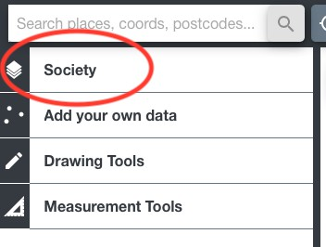

1. Scroll down to the Household section of available layers and click on the ‘Households that are socially rented’

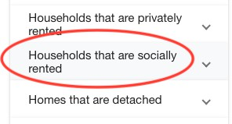

1. The map view will update and display the percentage of households that are socially rented across Great Britain. Ensure you are zoomed out to view the whole country.

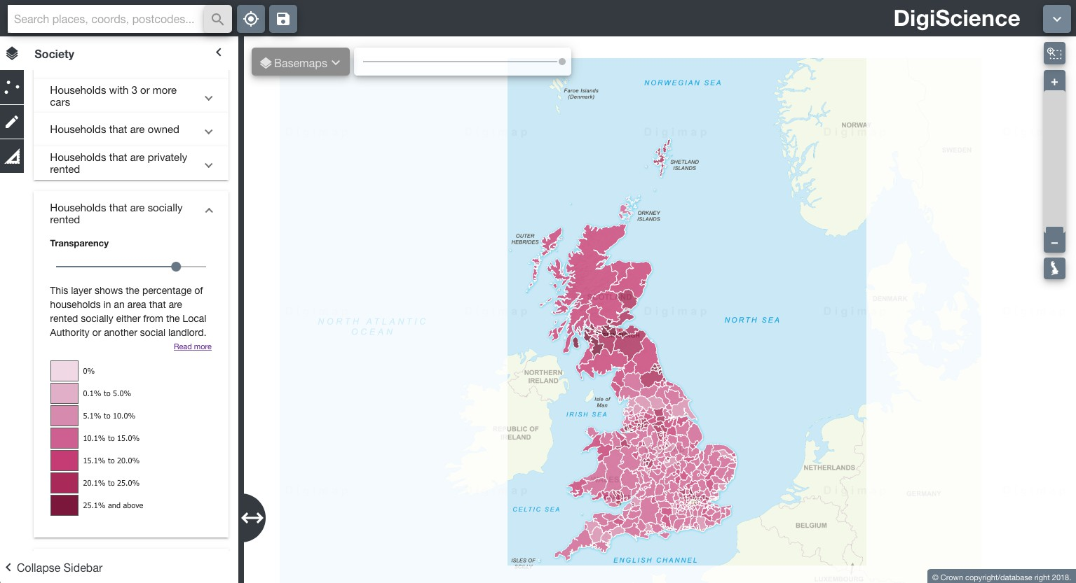

1. Explore the data by zooming in (double-click the mouse or use the zoom bar on the top right) and panning the map.

**Questions, Analysis and Interpretation**

* + Are socially rented houses evenly distributed across the UK?
  + Do all Scottish Local authorities provide comparable levels of socially rented houses?

**Exercise 2.**

Explore a single Scottish Local Authority in more detail.

1. Click on the map to select a single Local Authority. The selected authority will be highlighted with a red outline and the full statistics for the authority will appear on the left-hand panel.

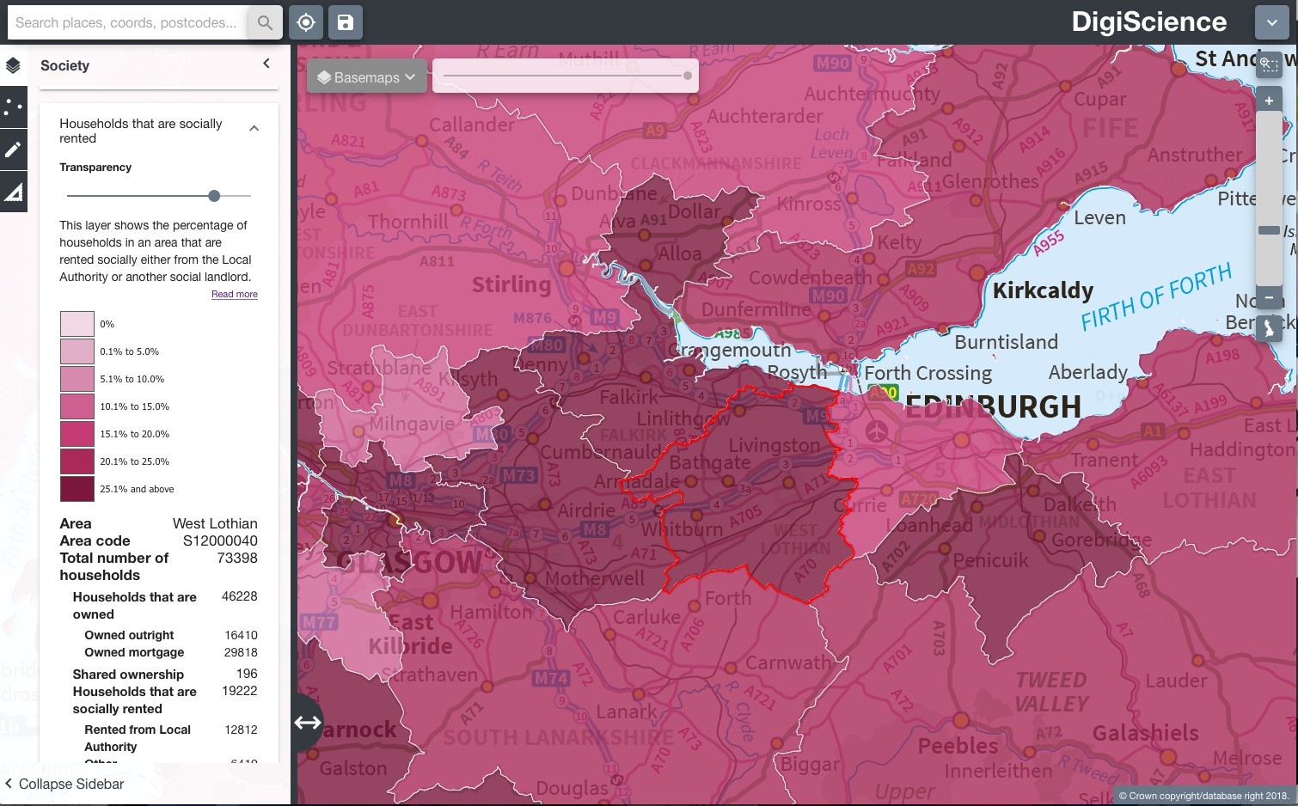

The data on the left-hand panel shows all the related statistics for that area in the Household Tenure dataset. It shows the total number of households in the selected area, and then breaks down in more detail characteristics of the households. For example, number of houses that are owned outright and those that are mortgaged.

**Questions, Analysis and Interpretation**

* + Describe the data under ‘Households that are socially rented’ for your selected Local Authority
  + Compare with some other authorities (selecting one at a time)

**Exercise 3.**

1. Download the data for a selection of authorities one by one. Click on an authority to select it as in Exercise 2.
2. Then click the **download** button in the left-hand panel

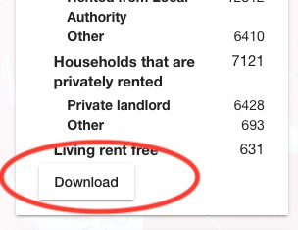

1. 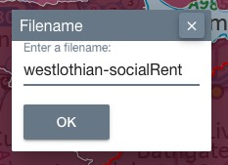Next, enter a name for your file and click ok.
2. Your data will be downloaded as a CSV file, navigate to where it has been saved on your computer and double click to open it in Excel.

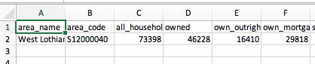

1. Repeat these steps to download data for a selection of Local Authorities.
2. Open your data in Excel and copy and paste into a single worksheet

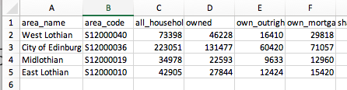

**Questions, Analysis and Interpretation**

* + Organise and present the data to support your interpretation of the current picture of housing tenure in Scottish Local Authorities.
  + Consider alternative ways to present the data than as a map, for example of different types of charts in Excel. Does this lead to different interpretations of the data?

